**1. Write a Java program that generates the Fibonacci series up to a specified limit and prints the prime numbers from 1 to 20. The program should use two threads, one for each task. The threads should be started one after the other, and each thread should pause its execution for 4 seconds using the sleep method.**

**→**

import java.io.*;

import java.util.Scanner;

class Fibonacci extends Thread

{

public void run()

{

try

{

int a=0, b=1, c=0;

System.out.print("Enter the limit: ");

Scanner sc = new Scanner(System.in);

int n = sc.nextInt();

System.out.println("Fibonacci series: ");

while(n>0)

{

System.out.print(c+ " ");

a = b;

b = c;

c = a + b;

n = n - 1;

}

}

catch(Exception ex)

{

ex.printStackTrace();

}

}

}

class Prime extends Thread

{

public void run()

{

try

{

int i=1,j;

System.out.println("\nPrime numbers from 1-20 : ");

while(i<=20)

{

if (isPrime(i))

{

System.out.println(i);

}

i++;

}

}

catch(Exception ex)

{

ex.printStackTrace();

}

}

public boolean isPrime(int n)

{

if (n <= 1)

return false;

for (int i = 2; i < n; i++)

if (n % i == 0)

return false;

return true;

}

}

class Main

{

public static void main(String[] args)

{

try

{

Fibonacci obj1 = new Fibonacci();

obj1.start();

obj1.sleep(4000);

Prime obj2 = new Prime();

obj2.start();

obj2.sleep(4000);

}

catch (Exception ex)

{

ex.printStackTrace();

}

}

}

**o/p :**

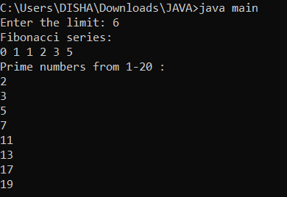

**2. Write a Java program that creates three threads and sets their priorities to maximum, minimum, and normal. The program should use the ThreadPriority class, which extends the Thread class and overrides the run method to print the name and priority of the current thread. The program should start all three threads and print their names and priorities.**

**→**

import java.io.*;

public class ThreadPriority extends Thread

{

public void run()

{

System.out.println("run() method "+getName());

String threadName = Thread.currentThread().getName();

Integer threadPrio = Thread.currentThread().getPriority();

System.out.println(threadName + " has priority " + threadPrio);

}

public static void main(String[] args) throws InterruptedException

{

ThreadPriority t1 = new ThreadPriority();

ThreadPriority t2 = new ThreadPriority();

ThreadPriority t3 = new ThreadPriority();

t1.setPriority(Thread.MAX_PRIORITY);

t2.setPriority(Thread.MIN_PRIORITY);

t3.setPriority(Thread.NORM_PRIORITY);

t1.start();

t2.start();

t3.start();

}

}

**o/p :**

